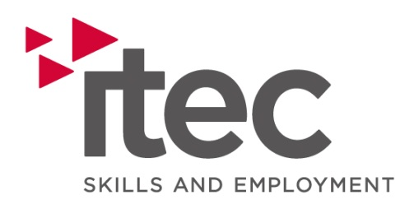

Job Description

Title: Marketing Assistant

Summary/Purpose: To support the Marketing function of the business with incentives, campaigns, helping to increase brand awareness, generate leads, drive sales and drive the marketing strategy that supports contract delivery and raises the overall profile of the business.

Reporting to: Marketing Executive

Supervising: N/A

Duties and Responsibilities:

Specific

- Assisting the Marketing Executive with creating content and development of marketing materials.
- Managing our social media presence by creating, scheduling and posting content across various platforms.
- Assisting in conducting market research to identify trends, competitor activities and potential opportunities.
- Assisting in the planning and execution of digital marketing campaigns to support revenue generation.
- Contributing to the researching, writing and editing of case studies that highlight success, demonstrating the effectiveness of our products through liaising with internal departments to obtain good news stories and staff achievements.
- Supporting the Marketing Executive with the production and delivery of internal communications.
- Assisting with the planning and organisation of events and attend relevant events to promote Itec as and when required.
- Supporting with the writing of letters and copy for communications including electronic newsletters.
- Assisting in the planning, execution and monitoring of marketing campaigns. Coordinating with internal teams and external partners to ensure timely delivery and alignment with objectives.
- Working closely with the Marketing Executive to protect the Itec brand.
- Assist the Marketing Executive with Marketing administrative tasks

General
- To ensure security of company assets
- To comply with all company policies and procedures
- To comply with the companies safeguarding policy & procedure
- To comply with Equal Opportunities Legislation and be proactive in challenging prejudice, discrimination and stereotyping.
- To implement in full the Company’s quality policies and procedures.
- To consult the Company Health and Safety Policy with regards to their specific responsibilities as described in the general arrangements section
- To give consideration to their actions at work as to how they may affect the safety of Learners, clients and visitors to Company premises
- Support and demonstrate the organisations core values
- Ownership mindset. Demonstrates accountability and reliability, taking responsibility for own actions and timely achievement of KPI’s.
- Co-operate with all staff to achieve a healthy and safe workplace and reporting any risks identified, at the company’s or others premises, to the designated Health and Safety Officer.
- Other duties that may be identified from time to time by the Company.
- Attend relevant training / personal development programmes

Person Specification
 | Essential | Desirable
Experience & Qualifications | Educated to degree level or equivalent  Proven Marketing Experience  Full driving licence with use of own vehicle | CIM qualifications or equivalent
Skills | Interpersonal skills  Strong written & verbal communication skills  Planning and organisational skills  Ability to work to deadlines and targets  Working knowledge of Microsoft Packages  Digital design skills | Working knowledge of Adobe creative suite or equivalent packages  Working knowledge of WordPress  Fluent in Welsh – written and spoken
Knowledge | Knowledge of social media trends, operations and tools such as Hootsuite  Knowledge of digital marketing trends, operations and tools – e.g. PPC, email marketing, analytics, CRM systems | Safeguarding Knowledge and understanding
Characteristics | Empowers others  Demonstrates a passion for learning  Demonstrates a commitment to inclusion  Fosters growth by proactively improving processes and practices  Creative  Self-motivated  Flexible in approach  Ability to work under pressure  Reliable  Enthusiastic  Team player

